https://www.weforum.org/stories/2026/04/africa-critical-minerals-energy-transition/

3 ways Africa can maximize the value of its critical minerals and finance its future
非洲最大化其关键矿产价值并为其未来融资的 3 种方式
Apr 3, 2026
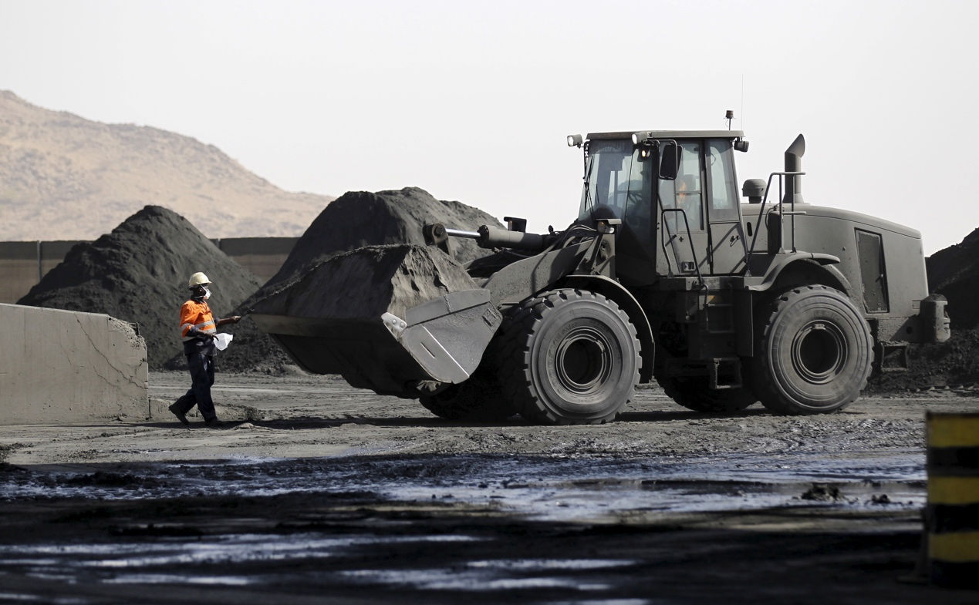
A worker collects samples for inspection from a pile of copper dust at a mine in Eritrea.
一名工人在厄立特里亚的一家矿场从一堆铜尘中收集样品进行检验。
Image: Reuters/Thomas Mukoya
图片：路透社/托马斯·穆科亚

Ifeanyi Chukwudi

Share: 分享：

Our Impact 我们的影响
What's the World Economic Forum doing to accelerate action on Energy Transition?
世界经济论坛正在采取哪些措施来加速能源转型行动？

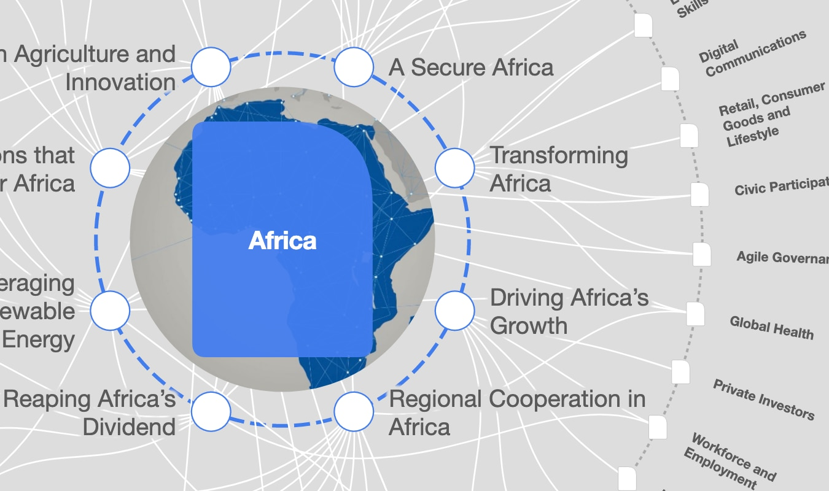
The Big Picture 大局观

Explore and monitor how Africa is affecting economies, industries and global issues
探索和监测非洲如何影响经济、产业和全球问题

Stay up to date: 保持更新：

Africa 非洲
Follow 关注
This article is part of:
本文是：Centre for Energy and Materials
能源与材料中心
- Africa does not sufficiently monetize its abundant critical mineral resources, exacerbating its development financing gap.
非洲没有充分货币化其丰富的关键矿产资源，加剧了其发展融资缺口。
- With growing demand for critical minerals for the energy transition, the continent has a key window for transforming its industrial strategies.
随着能源转型对关键矿物需求不断增长，非洲大陆有一个关键窗口来转型其工业战略。
- Increasing local processing, addressing the fiscal revenue gap, and building regional integration would help recapture African mineral wealth.
增加本地加工、解决财政收入差距以及建立区域一体化将有助于重新捕获非洲的矿物财富。
Africa faces a development financing gap of $1.6 trillion, consistently failing to meet its needs across health, education, energy and infrastructure. Traditional responses through foreign aid and debt relief have failed to close this gap, with official development assistance to Africa declining by 9% in 2024 and borrowing costs continuing to rise. But critical mineral assets offer an immediate alternative financing pathway.
非洲面临 1.6 万亿美元的 发展融资缺口，持续无法满足其在医疗、教育、能源和基础设施方面的需求。通过外国援助和债务减免的传统应对措施未能弥补这一缺口，2024 年对非洲的官方发展援助下降了 9%，而借贷成本仍在持续上升。但关键矿产资产提供了一个即时的替代融资途径。

Have you read? 你读过吗？
- How critical energy minerals could be Africa’s catalyst for sustainable development
如何关键矿产资源可能成为非洲可持续发展的催化剂
- The future of mining in Africa
非洲采矿业未来
- How Africa’s energy transition can break the resource curse
非洲能源转型如何打破资源诅咒
The continent holds an estimated 30% of the world's critical minerals, contributing about 75% of global cobalt production, 62% of manganese, while holding significant deposits of lithium, copper and rare earth elements. As demand driven by the global energy transition keeps rising, revenues from just four key minerals (copper, nickel, cobalt and lithium) are projected to reach $16 trillion over the next 25 years, with sub-Saharan Africa positioned to capture over 10% of that total. Yet African countries currently collect only about 40% of potential revenues from these resources. Three strategies can change this.
该大陆拥有全球约 30%的关键矿产资源，贡献了全球约 75%的钴产量、62%的锰产量，同时储藏着大量的锂、铜和稀土元素。随着全球能源转型带来的需求不断增长，预计未来 25 年内，仅铜、镍、钴和锂四种关键矿物的收入将达到 16 万亿美元，其中撒哈拉以南非洲将占据超过 10%的份额。然而，目前非洲国家仅能收集到这些资源潜在收入的约 40%。三种策略可以改变这一现状。

1. Increasing local processing and beneficiation
1. 增加本地加工和精炼
Africa’s critical mineral wealth can directly finance its development by strategically moving up the value chain. Every stage of value addition that happens on African soil, from refining raw ore to producing battery-grade materials, will generate tax revenue, create employment and retain foreign exchange that would otherwise leave with the unprocessed export. For decades, the continent has exported the raw materials of global industrialization while importing finished products at a premium, capturing less than 1% of the total economic value of the green technologies its minerals make possible.
非洲的关键矿产财富可以通过战略性地提升价值链直接为其发展提供资金。在非洲本土发生的每一阶段价值增值，从提炼原始矿石到生产电池级材料，都将产生税收收入，创造就业机会，并保留本应随未加工出口而流失的外汇。几十年来，这个大洲出口了全球工业化的原材料，同时以高价进口成品，其矿产所支持的绿色技术总经济价值中，所获得的不到 1%。
The gap between what Africa mines and what it processes is particularly wide for cobalt: Despite the DRC accounting for two-thirds of global mined cobalt in 2024, nearly all output is exported with minimal processing. The chart below shows this pattern across key minerals, with Africa's share collapsing at every stage beyond extraction.
非洲开采和加工的差距对于钴来说尤其明显：尽管刚果民主共和国在 2024 年占全球开采钴的三分之二，但几乎所有产出都未经充分加工就出口。下表显示了这一模式在关键矿产中的表现，非洲的份额在开采阶段之后每个环节都在萎缩。
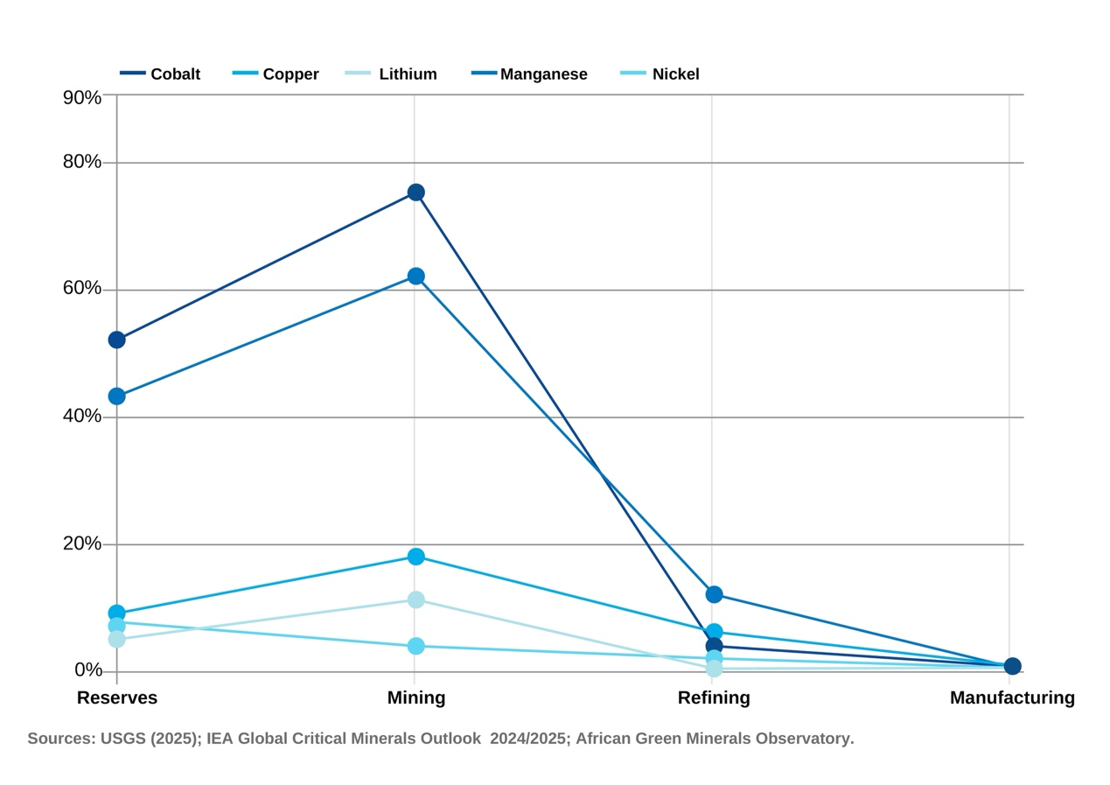
Minerals value flows out of Africa following extraction.
矿产价值在开采后从非洲流出。Image: USGS; IEA; African Green Minerals Observatory
图片：USGS；IEA；非洲绿色矿物观测站
Refining these critical minerals can add a further 15-30% premium at each processing stage; value that currently leaves Africa.
提炼这些关键矿物可以在每个加工阶段再增加 15-30%的溢价；而目前这些价值正流失出非洲。
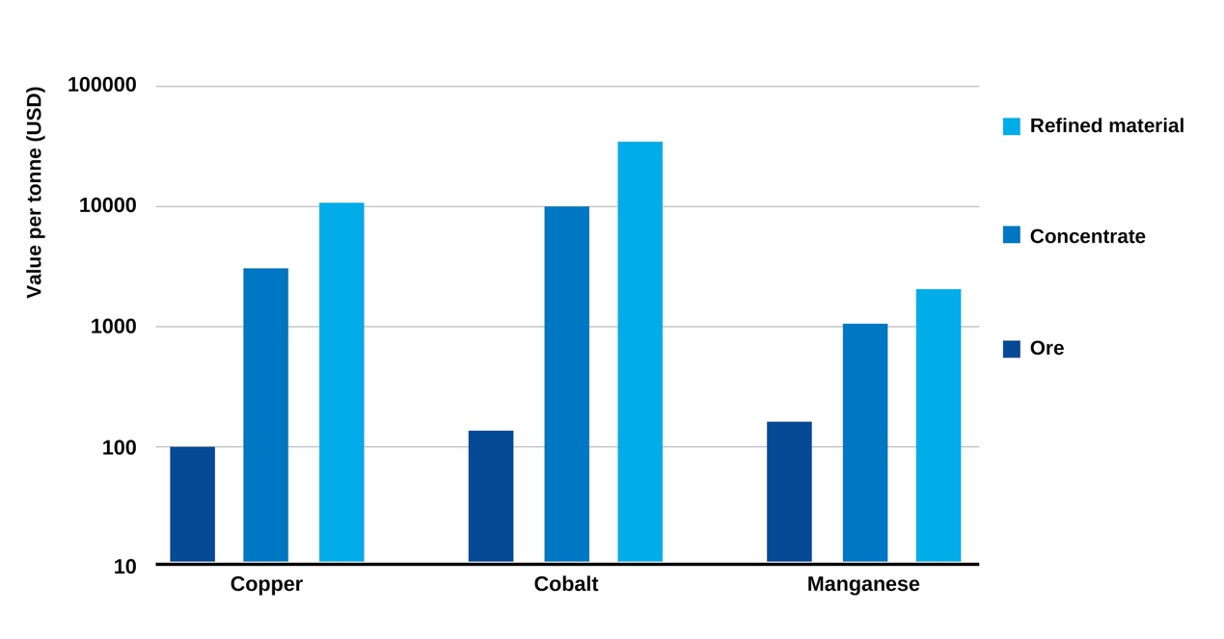
Value per tonne of material at different processing stages (2024)
材料每吨价值在不同加工阶段（2024 年）Image: IEA 图片：IEA
The IEA projects that the total market value of Africa's key refined minerals could rise from roughly $70 billion today to $120 billion by 2040, driven by moving a greater share of production through domestic processing. If done at scale, pursuing beneficiation (the treatment of raw materials) could indeed raise the continent's GDP by 12% and create approximately 2.3 million high-quality industrial jobs.
国际能源署（IEA）预计，非洲关键精矿的总市场价值将从目前的约 700 亿美元上升到 2040 年的 1200 亿美元，这是由于更大比例的生产通过国内加工。如果规模实施，追求精炼（对原材料的处理）确实可以提高该大陆的 GDP12%，并创造大约 230 万个高质量的工业岗位。
Therefore, the strategic imperative must be to provide the conditions that make processing investment viable and fiscally productive. This means designing investment frameworks that link capital entry to genuine value addition commitments, rather than allowing processing promises to remain unenforceable aspirations. It means directing finance toward the energy infrastructure and industrial corridors that processing facilities require. And ultimately building the institutional capacity to monitor, enforce and progressively deepen those commitments over time.
因此，战略要务必须是提供使投资处理具有可行性和财政效益的条件。这意味着设计将资本投入与真实增值承诺相联系的投资框架，而不是让处理承诺保持为无法执行的愿望。这意味着将资金引导至处理设施所需能源基础设施和工业走廊。最终是建立监测、执行并逐步深化这些承诺的机构能力。

2. Closing the fiscal revenue gap
2. 关闭财政收支缺口
While beneficiation captures the long-term prize, reforming the fiscal architecture of extraction could generate significant development revenue in the near term. Tax incentives have a legitimate role in attracting capital to high-risk projects, but their current prevalence in Africa may be reaching a point of diminishing returns. Between 2014 and 2016, corporate income tax holidays granted to just two firms cost Sierra Leone $131 million, which was roughly equal to the country's entire 2024 budget deficit. In Guinea, mining-related tax expenditures, such as corporate income tax holidays, reduced mineral royalties and import duty exemptions on mining equipment, represented 24.4% of total national tax expenditure in 2019; IMF simulations suggest that modest reforms could generate revenue four times the size of the country's entire agriculture budget.
虽然效益提升能够赢得长期利益，但改革开采的财政架构可能在短期内产生显著的发展收入。税收优惠在吸引资本投入高风险项目方面具有合法作用，但它们目前在非洲的普遍程度可能已经达到了边际效益递减的阶段。2014 年至 2016 年期间，仅向两家公司提供的企业所得税免税期就使塞拉利昂损失了 1.31 亿美元，这几乎等于该国 2024 年整个预算赤字。在几内亚，与采矿相关的税收支出，如企业所得税免税期、降低矿产品专利费和采矿设备进口免税，2019 年占全国税收支出的 24.4%；国际货币基金组织的模拟显示，适度的改革可能产生的收入将是该国整个农业预算的四倍。
Thinking further ahead, Africa must rethink its incentive strategy and put greater emphasis on incentivizing value creation rather than extractive presence alone. These could be in the form of performance-linked incentives that are time-bound and tied to outcomes such as local value addition, technology transfer and infrastructure development.
进一步思考，非洲必须重新思考其激励策略，更加重视激励价值创造，而不仅仅是掠夺性存在。这些可以采取与绩效挂钩的激励形式，这些激励有时间限制，并与结果挂钩，例如本地价值增加、技术转让和基础设施建设。
Closing the revenue gap will also mean fixing the revenue leakage problem. Africa loses about $89 billion annually to illicit financial flows, with the extractives sector significantly exposed. The IMF estimates that sub-Saharan Africa loses $450-730 million annually in corporate income tax alone from profit-shifting by multinational mining companies. To address this, African governments must build state capacity for revenue management and close the loopholes that allow transfer pricing abuse (where companies manipulate prices charged between their own subsidiaries across jurisdictions to shift profits away from the country where the mineral is extracted, reducing their tax liability there). Every dollar protected from leakage is a dollar that does not need to be borrowed and can directly flow into the development finance pool Africa urgently needs.
缩小收入差距也意味着解决收入流失问题。非洲每年因非法资金流动损失约 890 亿美元，其中采掘业面临显著风险。国际货币基金组织估计，仅因跨国矿业公司利润转移，撒哈拉以南非洲每年就损失 45 亿至 73 亿美元的的公司所得税。为应对这一问题，非洲各国政府必须增强收入管理能力，并关闭允许转让定价滥用的漏洞（即公司通过在不同司法管辖区之间对其子公司之间收取的价格进行操纵，以将利润转移到矿产开采所在国以外的地区，从而降低在该地区的税收负担）。每一美元的保护都意味着无需借贷，可以直接流入非洲迫切需要的开发融资池。

3. Leveraging regional integration
3. 利用区域一体化
However, both strategies must be supported by regional integration to achieve scale. Africa's mineral endowment is geographically distributed, and no single country holds the full mineral basket required to anchor an integrated clean-energy value chain. This makes regional coordination an economic necessity.
然而，这两种策略都需要区域一体化来达到规模。非洲的矿产资源在地理上分布，没有任何一个国家拥有支撑一个综合清洁能源价值链所需的全部矿产资源。这使得区域协调成为经济上的必要条件。
The DRC-Zambia transboundary battery and electric vehicle special economic zone is the most concrete example. Collectively, Zambia and DRC hold 70% of the minerals needed for battery and EV production. A BloombergNEF study confirmed a joint precursor plant is financially viable and building it in the DRC would cost three times less than an equivalent facility in the United States, demonstrating that Africa's processing proposition is commercially competitive.
DRC-赞比亚跨境电池和电动汽车特殊经济区是最具体的例子。总体而言，赞比亚和刚果（金）拥有电池和电动汽车生产所需矿物的 70%。彭博新能源财经的一项研究证实，联合建立前驱工厂在财务上是可行的，在刚果（金）建设它的成本将比美国同等设施低三倍，这表明非洲的加工提议具有商业竞争力。
The AfCFTA creates the architecture to scale this model. By aggregating demand, harmonizing investment standards and enabling shared infrastructure along mineral corridors, the AfCFTA can transform isolated national deposits into a regionally integrated industrial hub. With better coordination, revenues generated at each processing stage will be multiplied across economies.
AfCFTA 创建了扩展此模式的架构。通过聚合需求、协调投资标准并沿矿产走廊实现共享基础设施，AfCFTA 可以将孤立的国家级矿藏转变为区域一体化工业中心。通过更好的协调，每个加工阶段产生的收入将在经济体之间成倍增加。
Africa faces its largest development financing gap at precisely the moment when the global value of its mineral wealth has never been higher. Three forces make this moment particularly critical. The external financing model Africa has depended on for decades is breaking down, but simultaneously the global energy transition has created long-term demand for Africa's minerals that is written into the industrial strategies of major economies. Hence, policy decisions made now will determine the architecture of the clean energy economy for decades, with first movers capturing the dividends. But these conditions will not persist indefinitely, hence the need for urgency.
非洲正面临其历史上最大的发展融资缺口，而此时其矿产财富的全球价值却达到了前所未有的高度。有三股力量使这一时刻变得尤为关键。非洲依赖数十年的外部融资模式正在瓦解，但与此同时，全球能源转型为非洲的矿产创造了长期需求，这已写入主要经济体的工业战略。因此，当前的决策将决定清洁能源经济架构的几十年，而率先行动者将获得红利。但这些条件不会永远持续，因此迫切需要采取行动。
Increased local processing will raise revenues for Africa by capturing more value; fiscal reform will unlock the revenues already owed from ongoing extraction; and regional integration scales both by creating the market depth and investment attractiveness that individual countries cannot generate alone. On this path, Africa will move from a development financing model anchored in external dependency toward one built on the productive use of its resources.
提升本地处理能力将通过对更多价值的捕获来增加非洲的收入；财政改革将释放因持续开采而拖欠的收入；区域一体化通过创造单个国家无法独立产生的市场深度和投资吸引力而实现规模扩大。在这条道路上，非洲将从一个以外部依赖为基础的发展融资模式转向一个基于其资源有效利用的融资模式。

Don't miss any update on this topic
不要错过这个主题的任何更新
Create a free account and access your personalized content collection with our latest publications and analyses.
创建一个免费账户，使用我们的最新出版物和分析访问您的个性化内容收藏。
Sign up for free 免费注册
License and Republishing 许可和再发布
World Economic Forum articles may be republished in accordance with the Creative Commons Attribution-NonCommercial-NoDerivatives 4.0 International Public License, and in accordance with our Terms of Use.
世界经济论坛的文章可以根据知识共享署名-非商业性使用-禁止演绎 4.0 国际公共许可协议再发布，并遵守我们的使用条款。
The views expressed in this article are those of the author alone and not the World Economic Forum.
本文中表达的观点仅代表作者个人立场，与世界经济论坛无关。

